EAST PALO ALTO ACADEMY

STUDENT HANDBOOK

**TABLE OF CONTENTS**

# Student/Family Handbook Agreement Letter.........page 3

# Bulldog Basics & Campus Rules.............................page 5

# Dress Code Policy.....................................................page 6

# Attendance.................................................................page 7

# Academic Program....................................................page 9

# Advisory.....................................................................page 10

# Exhibition Overview..................................................page 14

# Early College Program..............................................page 14

# After School Opportunities.......................................page 14

# Transportation............................................................page 15

# Athletics Program......................................................page 15

# Positive Behavior.......................................................page 16

# Internet Use at School...............................................page 16

# Contact Information...................................................page 17

# Bell Schedule..............................................................page 18

# School Calendar 2016-2017.......................................page 19

# I. Student/Family Handbook Agreement Letter

# IMPORTANT - Please return this page to your advisor.



Dear East Palo Alto Academy Family,

Thank you for choosing East Palo Alto Academy for your student’s education and future. We value every student and family in our school community. This handbook is a tool to ensure that you and your student are aware of all the programs and policies of East Palo Alto Academy High School, so that every student and family receives the highest level of service at East Palo Alto Academy. Please read and sign the lower portion of this letter and make sure to return it to your student’s advisor.

*Ms. Amika Guillaume, M.Ed.*

Principal

*Sofia Hibbs, M.Ed.*

Vice Principal

*Maria Jose Flockhart, LCSW, M.Ed.*

Director of Student Wellness

I have read and understood the contents of this handbook. I understand that by signing below I have received all of the East Palo Alto Academy’s policies and agree to support my student on his/her path toward high school graduation and beyond.

________________________________________________

Parent/Guardian (print name)

________________________________________________

Parent/Guardian (signature) Date

________________________________________________

Student (print name)

________________________________________________

Student (signature) Date

**II. Bulldog Basics and East Palo Alto Academy Campus Rules**

**Bulldog Basics**

**BE RESPECTFUL**

in your language and in your behavior.

**BE RESPONSIBLE**

for your learning, your actions, your community, and your future.

**BE SAFE**

use good judgment on campus.

**East Palo Alto Academy Campus Rules**

* **Hall passes** are mandatory for all students out of class. Students may not leave class without permission at any time.
* **EPAA is a closed campus. Students are required to stay on school grounds at all times** during school hours.
* **Wheels must wait**. Anything with wheels may only be used OFF campus.

* **Take pride in our school.** Please do your part to keep it litter free.
* Consume food and/or drink in the cafeteria and/or courtyard only. **No food in classrooms.**
* **Water is the only beverage allowed in classrooms** with teacher permission.
* **All personal electronic devices at school are at your own risk. EPAA teachers, staff and administration are not responsible for lost or stolen items.**
* **Cell phones must remain on silent** and in your backpacks. Cell phones may only be used before or after school and during brunch or lunch

**If you have your phone out:**

•1st offense: Teacher takes it until the end of the period

•2nd offense: Teacher takes it and gives it to the office until the end of the day

•3rd offense: Teacher submits phone to Vice Principal and it is held until parents can meet with the Vice Principal and pick up the phone

**III. DRESS CODE POLICY:**

**Hats and Hoodies:**

* Sweatshirts with hoods must be worn with the **hood off during class and assemblies**
* Eyes and ears must be unobstructed
* Hats in violation of the dress code will be confiscated and returned at the discretion of the Administration

**Shirts and Tees:**

* Shirts must cover the students’ entire chest and stomach area
* Shirts must cover or tie across shoulders (no tube tops please)
* Clothing must be free of offensive language, references to/or symbols of drugs, alcohol or images of a sexual nature

**Pants, shorts and skirts:**

* If your pants are sagging, undergarment MUST be covered
* Shorts/skirts must be at least the length of half of the thigh

**The color RED or BLUE cannot be the majority of color in any outfit**

* Small amounts (less than 50%) of red and blue, with an even amount of each color in the garment or outfit
* Red and/or blue colors will be banned for students who with documented gang involvement at the discretion of administration

**Accessories:**

* No bandanas of any color are permitted on campus
* Sunglasses may not be worn during class

**Consequence for Dress Code Violation:**

Students will be given loaner items, if available, to wear for the day. Student may be asked to turn a shirt inside out. In some instances, parents will be called to bring a change of clothing. Student’s Advisor or administration may notify parents for a dress code violation. Repeated dress code violations could result in a parent conference and possible additional consequences.

**IV. Attendance Policy**

**ATTENDANCE POLICY**

Being in class all day, every day and on time is key to our students’ academic success. According to education code, a student must attend 60 hours of class to receive 5 units of credit. Parents or guardians must contact the school if his/her student will be absent. The school will be in immediate contact if there is a problem with attendance.

12 absences with 3 cuts = FA or NA

FA/NA means failure to attend and student **must retake the class**.

|  |  |
| --- | --- |
| **Excused Absences:**  A student’s absence shall be **excused** for the following reasons:   1. Personal illness 2. Medical appointments 3. Quarantine under the direction of a county or city health officer 4. Attendance at funeral services for a member of the immediate family 5. Jury Duty in the manner provided by law 6. Participation in religious instruction or exercises for less than five school days per month   In addition, a student’s absence shall be **excused for justifiable personal reasons**. Advance written requests by the parent/guardian shall be required for:   1. Appearance in court 2. Employment interview or conference 3. Attendance to immigration/citizenship status mandates 4. If a student is the custodial parent of a child, his/her absence shall be excused when the child is ill or has a medical appointment during school hours.   Upon return after absence, student/parent must present a satisfactory explanation verifying the reason for their absence.   1. Written note from parent/guardian, parent’s representative 2. Conversation, in person or by telephone, between the school and student’s parent/guardian 3. Physician’s verification   Parents/guardians and students are encouraged to schedule medical appointments during non-school hours. | **Unexcused Absences and Truancy:**  According to state law, students are classified as truant if absent from school without a valid excuse three full or partial days in one school year. The parent/guardian of a student who is classified as a truant shall be notified of the following:   1. The student is truant. 2. The parent/guardian is legally obligated to compel the student to attend school. 3. The parent/guardian who fails to meet this obligation may be guilty of an infraction of the law and subject to fines and legal action. 4. The parent/guardian has the right to meet with appropriate school personnel to discuss solutions to the student’s truancy. 5. The student may be subject to a truancy citation by police if absent from school without a valid reason and found by police. 6. The student may also be subject to restriction or delay of his/her driver’s license. 7. If a student is a ***habitual***truant (truant more than three times after an attempted school meeting), or is irregular in attendance at school, the student may be referred to a probation officer or district attorney mediation program |

**IT IS A STUDENT’S PERSONAL AND SOCIAL RESPONSIBILITY TO BE IN SCHOOL EVERYDAY.** Excessive absences negatively impact students’ grades and progress toward graduation.

**To Support and Ensure Good Attendance**

**East Palo Alto Academy has established the following procedures:**

**1. Parent / Guardian – Advisor Communication**

Advisor will:

* Create a positive relationship between the advisor and the family
* Learn about the student and family and collect information that will help support student learning
* Provide information about school policies and expectations, including attendance policies
* Review school-wide assessments including CELDT and CAASP, GMRT scores and answer any questions parents/guardians have regarding testing data received in the mail

**2. Immediate Follow-up of Absences**

Parents/guardians will be notified of their student’s absence by the district’s auto dialer. Each call and its outcome – who was reached, the content of the conversation -- will be logged in *Infinite Campus (IC)* or the main office log.

**3. Referral to Student Success Team (SST)**

After excessive unexcused absences (cutting class counts as an unexcused absence), the counselor or vice principal convenes an SST consisting of student, parent/guardian, advisor, administrator, and any other teachers as needed. Those teachers unable to attend will contribute feedback ahead of time through email or written documentation.

**Process / Product:** The team will create an individualized plan for improving attendance and ensuring academic success.

**4. Referral to District / County School Attendance Review Board**

# V. Academic Program

**I. Overview**

East Palo Alto Academy High School focuses on preparing students for college and careers. The majority of our classes are designated college preparatory and meet the California State University (CSU) and University of California (UC) subject requirements known as the **A-G requirements**. Classes in major subject areas such as English, Mathematics, Science, Social Sciences, Art, and Spanish are offered as year-long (2 semester) classes. Students also have the opportunity to enroll in Cañada College courses, which are taught on the East Palo Alto Academy campus. The college courses are one-semester courses and students earn both high school and transferable college credits for successfully passing with a grade of “C-” or better.

The standard amount of time for completing the high school requirements is four years. Students who need more time to gain proficiency in the English language or to complete their coursework may stay a fifth year to complete graduation requirements, as long as they maintain satisfactory attendance and conduct.

**II. Graduation Requirements**

**Credit Requirements –220 credits**

* Students are expected to earn a minimum of 220 credits in designated subject areas in four years. The standard schedule for most students consists of six classes per year with each class valued at 10 credits per year (60 credits/year).
* In addition to the six classes, students are also enrolled in a yearly advisory class (10 credits/year) and are expected to complete a grade-level exhibition each year, worth 5 credits. (See Credit Requirements Table).
* Students are expected to pass a minimum of 60 credits per year in order to stay on track for graduation within four years.

**Any student who is not on track to graduate MUST have a meeting with his/her Advisor, Guidance Counselor, Administration and Parent/Guardian to review his/her academic transcript and determine the best course of action for the individual student.**

**Early College classes** – Classes completed through Cañada College, Stanford University, or any other accredited college or university are worth approximately three times the credit amount of high school courses. For example, a 3-unit college course is equivalent to 10 high school credits. (See page 11).

**IV. East Palo Alto Academy Expected COLLEGE READY program of Study**

4 Years of English = 40 Credits

3 Years of History/Social Science = 30 Credits

3 Years of Math = 30 Credits

2 Years of Science = 20 Credits

2 Years of Same Language Other than English = 20 Credits

90 Credits of Arts, Electives & Exhibitions

**East Palo Alto Academy Expected Program of Studies,**

**Minimum Graduation Requirements, and A-G Requirements**

|  |  |  |
| --- | --- | --- |
| **Subject** | **East Palo Alto Academy Expected**  **COLLEGE READY**  **Program of Study** | **East Palo Alto Academy Minimum Graduation Requirements** |
| **English** | 40 units | 40 units |
| **Mathematics** | 30 units | 20 units |
| **Science** | 30 units, including 2 lab science courses | 20 units, including  1 lab science course |
| **History/Social Studies** | 30 units, including US History, World History, Government and Economics | 30 units, including US History, World History, Government and Economics |
| **Language Other Than Language** | 20 units | 10 units |
| **Arts** | 10 units | 10 units |
| **Electives** | 60 units (includes advisory and a UC approved electives) | 50-70 units (includes advisory and a UC approved electives) |
| **Exhibitions** | 20 units (5 earned per year) | 20 units (5 earned per year) |
| ***Total*** | ***240*** | ***220*** |

**III. Other Requirements**

Students must maintain a minimum of a 2.0 grade point average each semester in order to be eligible to play sports or to receive a work permit. Students may not go to work on days they are absent from school.

Students are expected to complete 25 hours of community and academic hours each year.

# VI. Advisory

East Palo Alto Academy provides each student with one advisor for their freshman and sophomore year, and a second advisor for their junior and senior year. Advisors serve as advocates who gather information on individual students’ needs as a whole child, and then connect the student to the resources to get their needs met.

|  |  |  |
| --- | --- | --- |
| Academic Monitoring | Social Emotional Learning | College Readiness |
| * Student Led Conferences * Grade Monitoring * Attendance Checks * Communication Between Advisors, teachers, Counselors and Administration | * Financial Literacy * Sex Education * Drug and Alcohol Abuse Prevention * Mental Health Awareness * Internet Etiquette | * College Visits * Financial Aid Guidance * College Application Support * Personal Statement Practice * Scholarship Application Support |

# 

# 

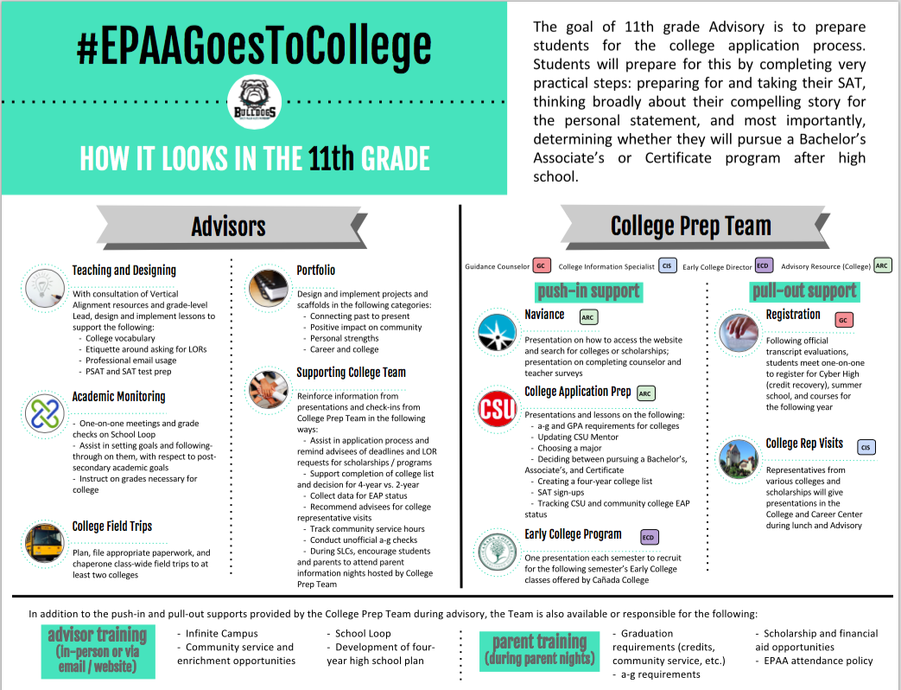

# 

# VII. Exhibition Overview

Students work closely with their advisor and classroom teachers to complete a yearly exhibition of work that represents their knowledge and skills in a core content area. Students will present each of the exhibitions to a judging panel that consists of teachers, students, and community members. Students will receive support to prepare for each Exhibition project in the core content class in which the Exhibition is based. Parents and families are STRONGLY ENCOURAGED to attend their Exhibition presentation. Students are expected to wear professional business attire on the day of his/her Exhibition presentation.

Students who successfully pass their exhibition receive 5 credits and fulfill an East Palo Alto Academy graduation requirement. Students who do not initially pass their exhibition will revise their Exhibition presentation, and re-present to their advisor and other available judges on the date and time set at the exhibition. Passing Exhibitions each year is a major step in students’ progression through high school and a positive sign that students can be successful in college.

**VIII. Early College Program**



East Palo Alto Academy has a partnership with Cañada College, know as our Early College program. Our goal is to have every East Palo Alto Academy student participate in the Early College program by the time they graduate. College classes are rigorous and require a serious commitment on the part of the student to work hard and complete all assigned reading and assignments.

This program allows all students:

* To earn both high school and college credit
* The ability to experience college level coursesfree of tuition
* To take college level courses on East Palo Alto Academy’s campus during the regular school day

Students will discuss college classes with their guidance counselor and the East Palo Alto Academy Early College Director before enrolling.

# IX. After School Opportunities

After school opportunities allow East Palo Alto Academy students to supplement their academic and social growth with support from our staff, alumni, and community partners. This opportunity is open to all students, with particular attention to those students who can most benefit from focused academic support.

**GOALS:**

* Support the academic growth of all East Palo Alto Academy High School students
* To provide meaningful enrichment experiences outside of the classroom
* To provide a safe and positive after-school environment where students can complete their schoolwork and enhance their college applications

**OPPORTUNITIES**

* Individual and group tutoring in the Bulldog College & Career Center
* Clubs such as Fly (Fresh Lifelines for Youth), BUILD, Black Student Union, and classes that includes dance, guitar, drumming and martial arts.
* Partnerships with Boys & Girls Club of the Peninsula, College Track, YUCA, and others

# X. Transportation

It is our privilege and pleasure to furnish students with the safest transportation possible as they travel between home and school and on school-related trips. We are also very fortunate to have three school vans to transport students to field trips, athletic events, and other school-related activities. In order to protect all students riding school buses and vans, safety precautions are a must!

All students are to understand that the bus driver is in charge of the bus at all times. Any student who violates the safety precautions and/or conduct rules may be denied the privilege of riding the bus and is subject to other disciplinary action to be determined by the administration.

**All school rules apply on the bus/van:**

1. Students must wait quietly in a location clear of traffic and away from the bus stop.
2. Student behavior at bus stops must not threaten life, limb, or property of any individual.
3. Students must remain seated, keeping aisles and exits clear.
4. Students must not engage in loud talking or laughing, excessive horseplay, or fighting.
5. Students must not throw or pass objects on, from or into the bus/van.
6. Students must not extend any part of their bodies out of the bus windows.
7. Seat belts, if provided, must be worn.

**XI. Athletics Program**

Students must maintain a minimum 2.0 Grade Point Average (GPA) and positive school behavior to be eligible to participate in East Palo Alto Academy Bulldog athletics. Student GPAs will be determined based on a standard letter grading scale with Incomplete, No Credits, and "F"s counting as "0" on a 4.0 grading scale. GPA determination will be made at the most recent marking period, whether quarter or semester, and will be determined based on when the grade comes out.

# XII. Positive Behavior

East Palo Alto Academy is a campus committed to Restorative Justice and positive behavior supports. All students will be supported with clear and consistent rules, procedures and expectations. There are, however, some behaviors for which there is zero tolerance:

* No Sexual Harassment
* No Drugs or Alcohol (this includes being under the influence, using on campus, possession, or selling)
* No use of physical force, threat of physical force or intimidation
* No Bullying: This includes intimidation, threats of physical bullying made in person, on social media, or any other form of communication
* No Hate Speech: Students will not use language that offends, threatens, or insults groups, based on race, color, religion, national origin, sexual orientation, disability, or other traits.

# XIII. Internet/Technology Use at School

**Children's Internet Protection Act (CIPA)**

Policy Notification

It is the policy of **East Palo Alto Academy** to:

(a) Prevent user access over its computer network to, or transmission of, inappropriate material via Internet, electronic mail, or other forms of direct electronic communications

(b) Prevent unauthorized access and other unlawful online activity

(c) Prevent unauthorized online disclosure, use, or dissemination of personal identification information of minors and staff

(d) Comply with the Children’s Internet Protection Act

[Pub. L. No. 106-554 and 47 USC 254(h)].

**Acceptable Use Policy (excerpts)**

Each school year, students are required to sign an Acceptable Use Agreement for Internet Access. Parents/guardians and advisors must also read and sign this agreement. Below are some important highlights of the agreement.

**User Responsibilities - User Must:**

* Use the network in accordance with school’s code of conduct.
* Cite sources of information properly. Users must obtain the author’s permission before placing copyrighted material on the system and may download copyrighted material for their own use only.
* Use the network only for purposes related to education. Commercial, political, and/or personal use unrelated to an educational purpose is strictly prohibited.
* Be courteous and respectful in their messages to others.
* Use appropriate language
* Not take or post pictures of any other students or adults unless given written signed permission

**Personal Safety - Users are expected to:**

* Use only their account and password and keep their password private. Report to a teacher or administrator any unsolicited email, security problems, or information that makes them uncomfortable.
* Recognize that email and computer files are not guaranteed to be private. East Palo Alto Academy HS will make reasonable efforts to protect the electronic files of every user. However, a user’s files may be reviewed, collected, and/or used by East Palo Alto Academy HS: (a) as required by law, (b) as part of system maintenance activity, (c) when there is reason to believe an account is being used improperly or illegally, or (d) with the permission of the account holder.
* Use the school address and phone number only. Students should refrain from revealing their image, home address or phone numbers, or those of other students or colleagues.

**Inappropriate Use** - Each user is held responsible for their actions and activity on the network. Unacceptable uses of the network will result in the suspension or revoking of these privileges. The principal or designee shall make all decisions regarding whether or not a user has violated these regulations and may deny, revoke or suspend a user’s access at any time. The decision of the principal or designee shall be final.

# 

# XIV. Contact Information

**EAST PALO ALTO ACADEMY**

**1050 MYRTLE STREET**

**EAST PALO ALTO, CA 94303**

**(650) 839-8900 telephone**

**(650) 839-8902 fax**

Attendance Clerk, Viridiana Magallon

(650) 839-8900 ext. 78000

[vmagallon@seq.org](mailto:vmagallon@seq.org)

Principal, Amika M. Guillaume

(650) 839-8900 ext.78010

[aguillaume@seq.org](mailto:aguillaume@seq.org)

Vice Principal, Sofia Hibbs

(650) 839-8900 ext. 78015

[shibbs@seq.org](mailto:shibbs@seq.org)

**XV. Bell Schedule**

# 